MODULE 4.4-Practical Project Assignment ABHISHEK ALLABOINA
https://learn.microsoft.com/en-us/sql/t-sql/language-reference?view=sql-server-ver17

--1) Create Database command
CREATE DATABASE InsuranceDB;
USE InsuranceDB;

--2) Create table commands for all the tables with constraints, relationships etc.
CREATE TABLE Customers (
CustomerID INT IDENTITY(1,1) CONSTRAINT PK_Customers PRIMARY KEY,
FirstName VARCHAR(20) NOT NULL,
LastName VARCHAR(20),
DateOfBirth DATE,
Phone VARCHAR(20),
Email VARCHAR(20) UNIQUE
);

CREATE TABLE Policies (
PolicyID INT IDENTITY(1,1) CONSTRAINT PK_Policies PRIMARY KEY,
PolicyName VARCHAR(20),
PolicyType VARCHAR(20),
PremiumAmount DECIMAL(10,2),
DurationYear INT
);

CREATE TABLE Agents (
AgentID INT IDENTITY(1,1) CONSTRAINT PK_Agents PRIMARY KEY,
AgentName VARCHAR(20),
Phone VARCHAR(15),
City VARCHAR(20)
);

CREATE TABLE PolicyAssignments (
AssignmentID INT IDENTITY(1,1) CONSTRAINT PK_PolicyAssignments PRIMARY KEY,
CustomerID INT,
PolicyID INT,
AgentID INT,
StartDate DATE,
EndDate DATE,

CONSTRAINT FK_PolicyAssignments_Customers
FOREIGN KEY (CustomerID) REFERENCES Customers(CustomerID),

CONSTRAINT FK_PolicyAssignments_Policies
FOREIGN KEY (PolicyID) REFERENCES Policies(PolicyID),

CONSTRAINT FK_PolicyAssignments_Agents
FOREIGN KEY (AgentID) REFERENCES Agents(AgentID)
);

CREATE TABLE Claims (
ClaimID INT IDENTITY(1,1) CONSTRAINT PK_Claims PRIMARY KEY,
AssignmentID INT,
ClaimDate DATE,
ClaimAmount DECIMAL(10,2),
ClaimStatus VARCHAR(20),

CONSTRAINT FK_Claims_PolicyAssignments
FOREIGN KEY (AssignmentID) REFERENCES PolicyAssignments(AssignmentID)
);

SCHEMA DIAGRAM FOR INSURANCE DATABASE:

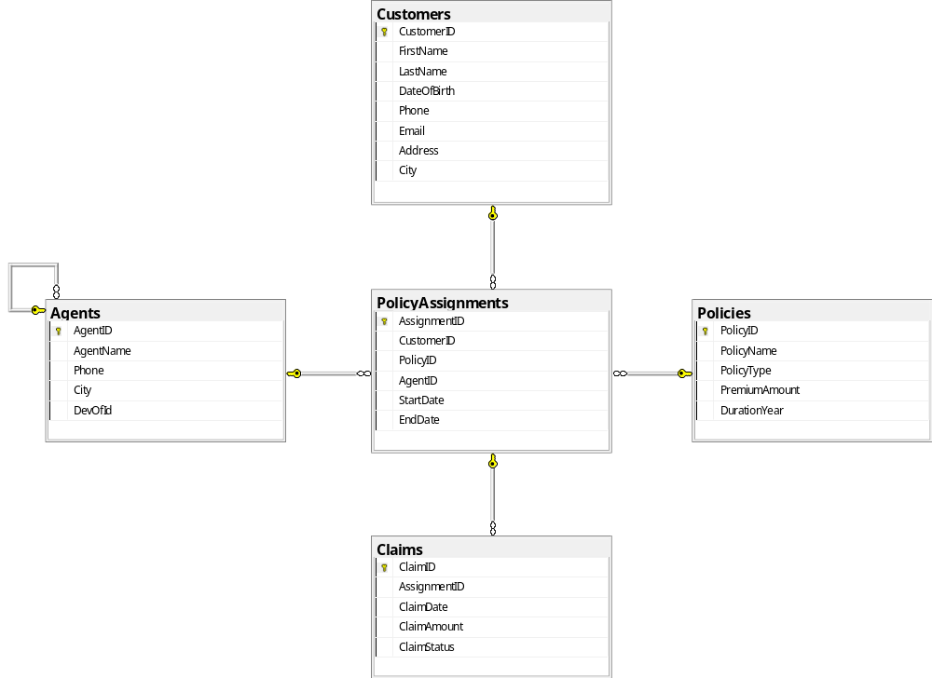

Insert commands for all tables.
INSERT INTO Customers (FirstName, LastName, DateOfBirth, Phone, Email)
VALUES
('Abhi', 'Shek', '2004-07-03', '7075268421', 'abhishek@gmail.com'),
('Santhu', 'Chepuri', '2004-05-24', '9080706050', 'chepuri@gmail.com');

INSERT INTO Policies (PolicyName,PolicyType,PremiumAmount,DurationYear)
VALUES
('Life Term', 'Life', 15000.00, 20),
('Health Plus', 'Health', 12000.00, 10);

INSERT INTO Agents (AgentName, Phone, City)
VALUES
('Spoorthik', '7867867867', 'Karachi'),
('Idries', '7867867866', 'Rawalpindi');

INSERT INTO PolicyAssignments
(CustomerID, PolicyID, AgentID, StartDate, EndDate)
VALUES
(1, 1, 1, '2025-01-01', '2045-01-01'),
(2, 2, 2, '2025-06-01', '2035-06-01');

INSERT INTO Claims
(AssignmentID, ClaimDate, ClaimAmount, ClaimStatus)
VALUES
(1, '2026-02-15', 50000.00, 'Approved'),
(2, '2026-03-10', 30000.00, 'Pending');

INSERT INTO Customers (FirstName, LastName, DateOfBirth, Phone, Email)
VALUES
('Varun', 'Kumar', '1999-08-12', '9001112233', 'varun@gmail.com'),
('Bhanu', 'Prakash', '1998-03-25', '9002223344', 'bhanu@gmail.com'),
('Ramu', 'Reddy', '2000-12-05', '9003334455', 'ramu@gmail.com');

INSERT INTO Policies (PolicyName, PolicyType, PremiumAmount, DurationYear)
VALUES
('Life Term', 'Life', 18000.50, 25),
('Health Shield', 'Health', 9500.75, 12),
('Car Protect', 'Vehicle', 7200.00, 5);

INSERT INTO Agents(AgentName,Phone,City)
VALUES
('Anil', '9876543210', 'Delhi'),
('Suresh', '9223344556', 'Hyderabad');

INSERT INTO PolicyAssignments
(CustomerID, PolicyID, AgentID, StartDate, EndDate)
VALUES
(3, 3, 1, '2023-01-10', '2048-01-10'),
(4, 4, 2, '2024-06-15', '2036-06-15'),
(5, 5, 1, '2025-03-01', '2030-03-01');

INSERT INTO Claims
(AssignmentID, ClaimDate, ClaimAmount, ClaimStatus)
VALUES
(3, '2024-11-20', 45000.00, 'Approved'),
(4, '2025-07-05', 15000.00, 'Rejected'),
(5, '2025-09-18', 8000.00, 'Pending');

INSERT INTO Customers (FirstName, LastName, DateOfBirth, Phone, Email)
VALUES
('sangu', 'Rao', '2002-02-10', '9876543210', 'sangu@gmail.com'),
('Manu', 'pal', '1998-11-15', '9876543211', 'manu@gmail.com');

INSERT INTO Policies (PolicyName, PolicyType, PremiumAmount, DurationYear)
VALUES
('Motor Secure', 'Motor', 11000.00, 1),
('Family Health', 'Health', 20000.00, 1);

INSERT INTO Agents (AgentName, Phone, City)
VALUES
('Rakesh', '9112233445', 'Bangalore'),
('Ajay', '9887766554', 'Chandigarh');

INSERT INTO PolicyAssignments (CustomerID, PolicyID, AgentID, StartDate, EndDate)
VALUES
(1, 6, 3, '2024-01-01', '2025-01-01'),
(2, 7, 4, '2025-02-01', '2026-02-01'),
(6, 4, 3, '2023-05-10', '2035-05-10');

INSERT INTO Claims (AssignmentID, ClaimDate, ClaimAmount, ClaimStatus)
VALUES
(6, '2025-03-15', 60000.00, 'Approved'),
(7, '2025-05-20', 25000.00, 'Rejected');

SELECT ,UPDATE ,DELETE COMMANDS:
1: Display policies having premium amount more than 10000 and DurationYears is 1
Select * from Policies Where PremiumAmount>10000 AND DurationYear=1;
2: List policies of type Life, Health, Motor use IN operator
SELECT * FROM Policies
WHERE PolicyType IN ('Life','Health','Motor');
3:Display list of customers born after January 1 st , 2001 and before December 31 st , 2020 using between operator
SELECT * FROM Customers WHERE DateOfBirth BETWEEN'2001-01-01' AND '2020-12-31';
4: Display records of Agents who stay in a city whose second letter is ‘a’
SELECT * FROM Agents WHERE City LIKE '_a%';
5: Display latest claim record
select top 1* from Claims
order by ClaimDate;

6: Increase premium amount to 10% for all health insurance policies
SET PremiumAmount=PremiumAmount*1.10
WHERE PolicyType='Health';
7: Delete the record of PolicyAssignments whose EndDate is before today&#39;s date.
DELETE FROM PolicyAssignments
WHERE EndDate < GETDATE();
error:
Msg 547, Level 16, State 0, Line 236
The DELETE statement conflicted with the REFERENCE constraint "FK_Claims_PolicyAssignments". The conflict occurred in database "InsuranceDB", table "dbo.Claims", column 'AssignmentID'.
The statement has been terminated.
DELETE FROM Claims
WHERE AssignmentID IN (
SELECT AssignmentID
FROM PolicyAssignments
WHERE EndDate < GETDATE()
);
DELETE FROM PolicyAssignments
WHERE EndDate < GETDATE();

AGGREGATE FUNCTIONS:
8. Total number of customers
SELECT COUNT(*) AS TotalCustomers
FROM Customers;
9. Average premium amount for each policy type
SELECT PolicyType, AVG(PremiumAmount) AS AvgPremium
FROM Policies
GROUP BY PolicyType;
10. Total premium value of all policies
SELECT SUM(PremiumAmount) AS TotalPremiumAmount
FROM Policies;
11.Total claim amount by claim status
SELECT ClaimStatus, SUM(ClaimAmount) AS TotalClaimAmount
FROM Claims
GROUP BY ClaimStatus;
12. Maximum and minimum premium amount
SELECT
MAX(PremiumAmount) AS MaxPremium,
MIN(PremiumAmount) AS MinPremium
FROM Policies;

Date & Time Functions
13. Extract year from customer date of birth
SELECT FirstName, YEAR(DateOfBirth) AS BirthYear
FROM Customers;
14. Extract month from policy start date
SELECT AssignmentID, MONTH(StartDate) AS StartMonth
FROM PolicyAssignments;
15. Calculate customer age
SELECT FirstName,
DATEDIFF(YEAR, DateOfBirth, GETDATE()) AS Age
FROM Customers;
16. Policy duration in years using dates
SELECT AssignmentID,
DATEDIFF(YEAR, StartDate, EndDate) AS PolicyDurationYears
FROM PolicyAssignments;
17. Claims raised in the last 1 year
SELECT *
FROM Claims
WHERE ClaimDate >= DATEADD(YEAR, -1, GETDATE());
18. Get month name of claim date
SELECT ClaimID,
DATENAME(MONTH, ClaimDate) AS ClaimMonth
FROM Claims;

QUERIES USING JOINS, HAVING ,GROUPBY
19.List all Policies for a CustomerId 5
SELECT p.* FROM Policies p
JOIN
PolicyAssignments pa
ON p.PolicyID = pa.PolicyID WHERE pa.CustomerID = 5;

20: Display FirstName, PolicyName, AgentName, StartDate and EndDate from their
respective tables
select FirstName,PolicyName,AgentName,StartDate,EndDate
FROM PolicyAssignments pa
join Customers c on pa.CustomerID=c.CustomerID
join Policies p on pa.PolicyID=p.PolicyID
join Agents a on pa.AgentID=a.AgentID;

21: Display claims report with FirstName, PolicyName, ClaimAmount, ClaimStatus, and
ClaimDate from their respective tables
SELECT c.FirstName, p.PolicyName,
cl.ClaimAmount, cl.ClaimStatus, cl.ClaimDate
FROM Claims cl
JOIN PolicyAssignments pa ON cl.AssignmentID = pa.AssignmentID
JOIN Customers c ON pa.CustomerID = c.CustomerID
JOIN Policies p ON pa.PolicyID = p.PolicyID;

22: Display records of Customers with or without Policies
SELECT c.CustomerID,c.FirstName,p.PolicyName,p.PolicyID
FROM Customers c
LEFT JOIN PolicyAssignments pa ON c.CustomerID = pa.CustomerID
LEFT JOIN Policies p ON pa.PolicyID = p.PolicyID;
23: Show names and total claim amount of Customers With Claim Amount greater than 50000 (Use HAVING Clause)
select concat(c.FirstName,c.LastName) as FullName,
sum(cl.ClaimAmount) as TotalClaim
from Customers c
join PolicyAssignments pa on pa.CustomerID=c.CustomerID
join Claims cl on cl.AssignmentID=pa.AssignmentID
group by c.FirstName,c.LastName
having sum(cl.ClaimAmount)>50000;
24: Display list with Agent Wise Policy Count
SELECT a.AgentName,COUNT(pa.AgentID) AS PolicyCount
FROM Agents a JOIN PolicyAssignments pa ON
a.AgentID=pa.AgentID group by a.AgentID,a.AgentName;
SUBQUERIES:
25. Customers who have NOT taken any policy
SELECT *
FROM Customers
WHERE CustomerID NOT IN (
SELECT CustomerID
FROM PolicyAssignments
);
26. Policies with premium higher than the average premium
SELECT *
FROM Policies
WHERE PremiumAmount > (
SELECT AVG(PremiumAmount)
FROM Policies
);
27. Policy with the highest premium amount
SELECT *
FROM Policies
WHERE PremiumAmount = (
SELECT MAX(PremiumAmount)
FROM Policies
);
28. Agents who have not handled any claims
SELECT *
FROM Agents
WHERE AgentID NOT IN (
SELECT AgentID
FROM PolicyAssignments PA
JOIN Claims C ON PA.AssignmentID = C.AssignmentID
);

29. Customers who have more than one policy
SELECT *
FROM Customers
WHERE CustomerID IN (
SELECT CustomerID
FROM PolicyAssignments
GROUP BY CustomerID
HAVING COUNT(*) > 1
);

CASE, ROLLUP, CUBE & GROUPING
30. Categorize policies based on premium amount (CASE)
SELECT PolicyName, PremiumAmount,
CASE
WHEN PremiumAmount < 10000 THEN 'Low Premium'
WHEN PremiumAmount BETWEEN 10000 AND 15000 THEN 'Medium Premium'
ELSE 'High Premium'
END AS PremiumCategory
FROM Policies;
31. Count policies by premium category

SELECT
CASE
WHEN PremiumAmount < 10000 THEN 'Low'
WHEN PremiumAmount BETWEEN 10000 AND 15000 THEN 'Medium'
ELSE 'High'
END AS PremiumCategory,
COUNT(*) AS PolicyCount
FROM Policies
GROUP BY
CASE
WHEN PremiumAmount < 10000 THEN 'Low'
WHEN PremiumAmount BETWEEN 10000 AND 15000 THEN 'Medium'
ELSE 'High'
END;

32.Identify subtotal rows using GROUPING function
SELECT
ClaimStatus,
SUM(ClaimAmount) AS TotalClaimAmount,
GROUPING(ClaimStatus) AS IsSubtotal
FROM Claims
GROUP BY ROLLUP (ClaimStatus);
33. Claim count by Year and Status (Cube)
SELECT
YEAR(ClaimDate) AS ClaimYear,
ClaimStatus,
COUNT(*) AS ClaimCount
FROM Claims
GROUP BY CUBE (YEAR(ClaimDate), ClaimStatus);

SET OPERATIONS:

34: List all unique phone numbers from Customers and Agents
SELECT Phone FROM Customers
UNION
SELECT Phone FROM Agents;

35: Customers who have policies AND have raised claims
SELECT CustomerID
FROM PolicyAssignments
INTERSECT
SELECT PA.CustomerID
FROM PolicyAssignments PA
JOIN Claims C ON PA.AssignmentID = C.AssignmentID;
36:Customers who have policies but never raised a claim
SELECT CustomerID
FROM PolicyAssignments

EXCEPT

SELECT PA.CustomerID
FROM PolicyAssignments PA
JOIN Claims C ON PA.AssignmentID = C.AssignmentID;

